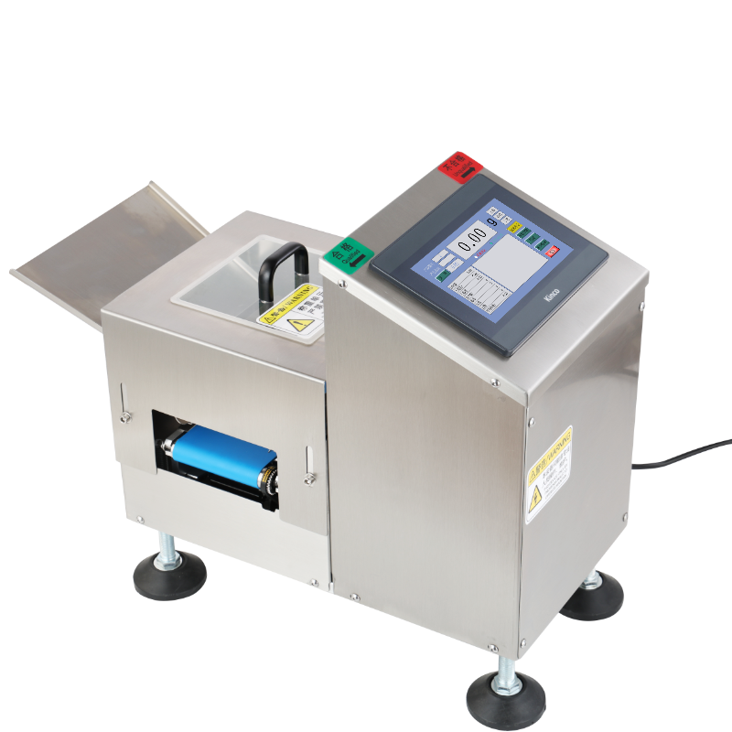
HL10100240 High-Precision Single-Stage Checkweigher

Applications
Suitable for checking whether the weight of individual products meets specifications. Widely used in electronics, pharmaceuticals, food, beverages, health products, daily chemicals, light industry, and agricultural products. Typical applications include prepared foods, pastries, sausages, instant noodles, frozen foods, food additives, colorants, modifiers, and preservatives.

Key Features
- Standardized machine structure and HMI for a wide range of products.
- Color touchscreen with user-friendly interface.
- Easy-to-remove conveyor for cleaning and maintenance.
- Variable-speed motor with adjustable conveyor speed.
- High-speed, high-accuracy weighing using a digital load cell.
- Manual/automatic zeroing and dynamic zero tracking.
- PC and smart device communication supported.
- Standard RS-485 (MODBUS RTU) and RS-232 communication.
- Optional custom RS-232 protocol for printers, inkjet coders, packaging machines and production lines.

Technical Specifications
Item | Specification
Model | HL10100240
Machine Type | High-Precision Single-Stage Checkweigher
Warranty | 3 Years
Weighing Range | 0–200 g
AD Module | A102
Sampling Rate | 850
Accuracy | ±0.01 g
Speed | 0–42 pcs/min
Machine Size | 565 × 281 × 400 mm
Weighing Platform | 100 × 240 mm
Frame Material | 1.5 mm SUS304 Stainless Steel
Machine Weight | 30 kg
Roller Material | Precision-machined SUS304
Platform Structure | Machined Aluminum

Main Components
Component | Brand / Specification
Timing Belt | Gates (USA)
Conveyor Belt | Yongli (Shanghai)
Bearings | SKF
Motor | Stepper Motor - Xinlichuan
Power Supply | Omron
Relay | Honeywell
Weighing System | Imported Chip
Touchscreen | Kinco
Load Cell | Mettler Toledo
Communication | RS-485
Touchscreen | Ethernet

